A different way of learning modes.

A mode is like a scale just starting on a different note!

Take a C Major scale. When you play the C major scale starting on C, it’s just like any other major scale. But if your start playing the C major scale on a D, it is a Dorian Mode, more specifically a D Dorian mode. If you take the same C major scale and play it from E to E, it is an E Phrygian mode. If you take the C Major scale and play it from F to F, it is an F Lydian mode. Each mode has a different name depending on what scale degree they start on!

Scale Degree | Mode Name | Pneumonic Device to Help with Memorization!
1 | Ionian | I
2 | Dorian | Don’t
3 | Phrygian | Play
4 | Lydian | Lousy
5 | Mixolydian | Modes
6 | Aeolian | Any
7 | Locrian | Longer

So, therefore..

C Ionian | C D E F G A B C
D Dorian | D E F G A B C D
E Phrygian | E F G A B C D E
F Lydian | F G A B C D E F
G Mixolydian | G A B C D E F G
A Aeolian | A B C D E F G A
B Locrian | B C D E F G A B

Let’s do a couple examples…

D Aeolian

First let’s determine what scale degree an Aeolian mode starts on: it’s the 6th! So, in what major scale is the note D the 6th degree in the major scale? That would be the F major scale!

F Major Scale
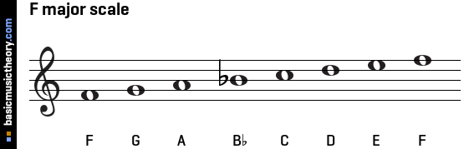

So, let’s write out that same scale starting on a D and ending on a D.

D Aeolian Mode

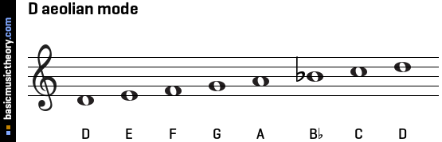

F# Mixolydian

Mixolydian Mode = 5th scale degree

In what major scale is F# the fifth scale degree?
B MAJOR!

Write out your B Major scale!

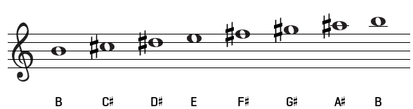

Now write that same scale from F# to F#!

F# Mixolydian Mode

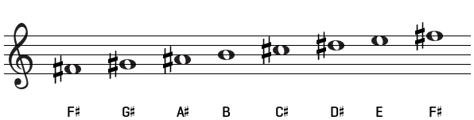

Dr. Wieland says…

It’s TEN O’CLOCK!
Now your modes are ready to ROCK!

